In-line monitoring/ Real-time release testing in biopharmaceutical processes– prioritization and cost benefit analysis
Version | Date | Modification | Responsible
1.0 | 28Feb2020 | First released version of white paper | Bela

About BioPhorum
The BioPhorum Operations Group’s (BioPhorum’s) mission is to create environments where the global biopharmaceutical industry can collaborate and accelerate its rate of progress, for the benefit of all. Since its inception in 2004, BioPhorum has become the open and trusted environment where senior leaders of the biopharmaceutical industry come together to openly share and discuss the emerging trends and challenges facing their industry. Growing from an end-user group in 2008, BioPhorum now comprises 53 manufacturers and suppliers deploying their top 2,000 leaders and subject matter experts to work in seven focused Phorums, articulating the industry’s technology roadmap, defining the supply partner practices of the future, and developing and adopting best practices in drug substance, fill finish, process development and manufacturing IT. In each of these Phorums, BioPhorum facilitators bring leaders together to create future visions, mobilize teams of experts on the opportunities, create partnerships that enable change and provide the quickest route to implementation, so that the industry shares, learns and builds the best solutions together.

BioPhorum Technology Roadmapping
The Technology Roadmapping Phorum establishes a dynamic and evolving collaborative technology management process to accelerate innovation by engaging and aligning industry stakeholders to define future needs, difficult challenges and potential solutions. The Phorum involves biomanufacturers, supply partners, academia, regional innovation hubs and agencies, serving to communicate the roadmap broadly while monitoring industry progress.
The project through which this paper has been developed is part of a broad portfolio of collaborative technology implementation projects, mobilized to impact the most critical challenges identified by the first edition of BioPhorum’s BioManufacturing Technology Roadmap https://www.biophorum.com/phorum/technology-roadmapping/trm-projects-2. This paper is an example of how the Phorum is continuing to deliver tangible results on its mission to accelerate industry innovation.
For more information on the Technology Roadmapping mission and membership, please see https://www.biophorum.com/phorum/technology-roadmapping/overview/.
Permission to use

Permission to use
The contents of this report may be used unaltered as long as the copyright is acknowledged appropriately with correct source citation, as follows “Entity, Author(s), Editor, Title, Location: Year”

Disclaimer
This document represents a consensus view, and as such it does not represent fully the internal policies of the contributing companies. Neither BioPhorum nor any of the contributing companies accept any liability to any person arising from their use of this document. The views and opinions contained herein are that of the individual authors and should not be attributed to the authors’ employers.

The following member company participants are acknowledged for their efforts and contributions in the production of this document and accompanying User Requirement Specifications

AstraZeneca – David Robbins, Jeremy Springall, Ken Miller, Rick Lu
Bayer – Rafal Garus, Robin Sundstroem
Biogen – John-Paul Smelko
Chugai Pharma Manufacturing Co., Ltd – Tohru Shimuta
Emerson – Benjamin Arriola, Brandon Haschke, Michael Francis, Michalle Adkins, Nathan Johnson
Endress + Hauser – Maryann Cuellar
Fujifilm Diosynth Biotechnologies – Jennifer Tovey
GE Healthcare – Gunnar Malmquist, Helena Ohrvik, Jozsef Vasi
GSK – Vakhtang Loladze
Lonza – Ben Wilkes, Justin Beller
Merck & Co., Inc., Kenilworth, NJ, USA – Bhumit Patel
Pall Biotech – Edita Botonjic-Sehic
Roche – Bingchuan Wei, Victor Saucedo
Sartorius Stedim – Christian Grimm
Thermo Fisher Scientific – Moira Lynch, Tony Hsiao
BioPhorum - Bela Green

Contributors
The team would like to thank the following non-member contributors:

Amgen - Tony Wang

Bioprocessing Technology Institute, Agency for Science, Technology and Research - Andre Choo, Ho Ying Swan

Bristol-Myers Squibb Udayanath Aich (previously Sanofi)

Table of Contents
1. Executive summary 4
2. Introduction 5
3. Process workflow 7
3.1 Process scope 7
3.2 Step attribute matrix 8
3.3 Current and desired state 10
3.4 Ranking 11
4. User requirement specifications 15
5. Business case 16
5.1 Benefits of ILM-RTRT 16
5.2 Drivers for ILM-RTRT 16
5.3 Business impact of the prioritized CQAs and CPPs 16
5.4 Building a business case 18
5.5 Business case model 21
5.6 Business case summary 29
6. Conclusion and path forwards 29
7. References 31
8. Definitions/Glossary 33

Executive summary
Biopharmaceutical product development and commercialization has been growing rapidly over the last couple of decades with biopharmaceutical sales equating to roughly 30% of all drug sales in 2018 at a growth rate of twice that of conventional pharmaceuticals [1]. Biopharmaceuticals are diverse, require multi-step processes for their production, and their molecular complexity far exceeds that of traditional small molecule drugs. The quality of a biopharmaceutical product is highly dependent on its manufacturing process and control strategy, requiring extensive product and process knowledge, leading to significant development costs of these highly complex products. Drug pricing, reimbursement constraints, volatile investment markets, expanding presence to emerging markets and diverse patient populations along with approval pressure from health authorities and regulatory requirements of each approving market are challenges that the biopharmaceutical industry must strive to address. There is a need to increase speed and reduce cost of development, manufacturing, and commercialization of biopharmaceutical products, to balance the significant challenges and promote availability of most needed medicines to patients. At the same time, providing high assurance of product quality and process consistency is of utmost importance.

Significant improvements in quality, consistency, speed of development and cost of biopharmaceutical products can be achieved by adopting quality by design (QbD) [2,3] principles and focusing process development on product and process understanding and process control to ensure acceptable product quality and process consistency. Important initiatives that go beyond the most basic QbD mindset and toolset to help accomplish this include the use of process analytical technology (PAT) [4], real-time release testing (RTRT) [5] and automation technologies. Additionally, the adoption of in-line monitoring (ILM) and RTRT of products will provide greater long-term beneficial impacts when compared to classical quality testing and release methodologies. Towards this endeavor, BioPhorum is working with representatives from the biopharmaceutical industry, including end users, supply partners and innovation hubs, to promote the technology roadmap into development and implementation of short-term real-time monitoring tools and long-term use of ILM and RTRT. The goals of an effective ILM-RTRT and predictive modelling strategy are to leverage enhanced process understanding, risk mitigation and process control improvement to reduce the reliance on end product testing (EPT) while improving early detection of catastrophic failure. Additionally, ILM and RTRT will enable cost reductions, product and process consistency and speed to market while enabling continuous improvement.

As part of the ILM-RTRT strategy, BioPhorum published the first edition of the Biomanufacturing Technology Roadmap in 2017 [6] and continues the effort towards implementation of the proposed strategy. The ILM-RTRT team has developed a unique approach to tackle the most demanding requirements based on a prioritization of industry needs for real-time monitoring of critical quality attributes (CQAs) and critical process parameters (CPPs). A detailed step-by-step approach for the development of user requirement specifications (URS) was prepared for a list of ten high priority attributes which was generated using a mathematical ranking methodology and subsequently refined using industry expert judgment. For this study, batch manufacturing processes and antibody platform technologies were used as a starting point with the potential to expand into other modalities and next-generation manufacturing capabilities, e.g. based on continuous manufacturing and/or single use approaches. A strategy for stating the business case for each attribute was developed to understand the return on investment (ROI) and potential future benefits created through the development and implementation of a combined ILM-RTRT approach. Described below are the three major sections of the white paper with a summary of content:

- Process workflow: This section describes a step-by step process matrix and the mathematical ranking methodology used to prioritize CQAs and CPPs based on industry ILM-RTRT requirements. It also describes critical control points (CCP) for each attribute, which are unit operations in which the attribute can be controlled through measurements using feed-back/feed-forward control to ensure that a quality attribute is within the desired range The CCP section is valuable for the prioritization and ranking of attributes and process parameters for their potential to benefit from implementation of ILM-RTRT.
- User requirement specification: A technology agnostic user requirement specification was prepared for each prioritized attribute based on the industry need, including safety and regulatory requirements for any potential technology to be developed or improved for use by the industry.
- Business case: This section describes the elements of business case calculations and the important considerations and assumptions for a selection of attributes. The examples are provided to act as a guideline for industry to understand and decide how to evaluate specific scenarios for an application of this type of technology.

Introduction
In 2004, FDA published its framework on Process Analytical Technology (PAT) [4] and since then the biopharmaceutical industry and its associated technology supply partners have poured resources into the development of innovative sensors, sampling strategies and modeling techniques to fulfill the framework outlined by FDA. The advancement of these sensors accelerated the industry’s focus away from off-line sampling and product release methods towards the use of automation and new PAT sensors to achieve in-line monitoring (ILM) and real-time release testing (RTRT). The term ILM is used broadly to describe timely measurements made to improve process control. Based on the time scale of the unit operation they can be performed by in-line/on-line or potentially at-line measurements. In 2008 and 2009 ICH added additional details to PAT and its integration with pharmaceutical development through its release of Q8 R1 and R2 guidance [2]. ICH defines RTRT as “the ability to evaluate and ensure the quality of in-process and/or final product based on process data, which typically includes a valid combination of measured material attributes and process controls”. Additional guidance on the application of RTRT has been provided by the regulatory authorities [7,8].

New regulatory tools were introduced in 2019 through ICH Q12 [9] that are expected to enable increased use and flexibility of ILM and RTRT implementation to improve product quality and process consistency in biopharmaceutical manufacturing. This guidance provides an opportunity for industry to propose a “performance-based approach” to process control in place of the parameter-based approaches previously used in regulatory submissions. In the performance-based approach, the legally binding elements of the process for which changes must be approved by or reported to regulatory agencies (“established conditions” or ECs) may shift from process inputs such as critical process parameters to control of process outputs such as ILM-RTRT measurements and responses, including feedback controls and optimization algorithms. Examples include the use of ILM outputs of a bioreactor or a process chromatography column as ECs to control product quality, with process inputs adjusted in real time using feedback controls based on the ILM outputs [10]. In these scenarios the critical process parameters would no longer be required to be regulated as ECs, provided certain requirements are met as described in the ICH Q12 guideline.

For the successful implementation of an ILM and RTRT workflow a good quality system is required to ensure the safety of the final product. ICH Q10 was published in 2009 and provides additional insight into how the process and the Quality system should be integrated [11]. Although ICH Q10 guidance will not be discussed in detail in this article, elements of this guidance can be found throughout the article as it contains important information for implementing ILM and RTRT in any process.

A few recent developments in the PAT area include mass spectrometry, microscopy-based cell counters, new optical chemical and biochemical analyzers and miniaturization of vibrational spectroscopy (Raman, NIR, IR). Additionally, advancements in chromatography and electromigration, mass spectrometry, multiplexing integrations and holistic system integration have helped to increase the adoption of these techniques for ILM and RTRT [12.13]. One of the most beneficial advancements to making RTRT possible is vibrational spectroscopy. It has revolutionized the industry by applying either univariate or chemometric models with the acquired sample spectra to enable detection of uniformity and dosage level in synthetic drugs as well as the development of multiple applications for monitoring and control in the upstream and downstream (purification) areas for biologics [14,15,16,17]. Although the initial investment of owning such a system is high, the long-term benefits and optimization opportunities it offers greatly swing the balance in its favor [17,18,19].

High Performance Liquid Chromatography (HPLC) instruments have been a work horse in the biopharmaceutical industry for many years. This technology is being used extensively to release drug products. Even with the advancements in spectroscopy, the core capabilities of a liquid chromatography system still cannot currently be replaced. Ultra-High Performance Liquid Chromatography (UHPLC) systems have gradually replaced the traditional HPLC as they offer the opportunity for faster and higher efficiency methods to be developed. However, the majority of methods rely on submission of samples which together with the finite time needed for the column separation limits how LC systems can be used to support ILM and process control. To be able to retain the analytical capability of the LC system but still allow trending of these results in near real-time fashion, the industry developed auto-sampling attachments that can be connected to the LC system. This type of automated sampling systems can be connected to the sample stream on-line and transfer the appropriate sample to the LC system at predefined schedules which can allow for near real-time trending and potentially [20] real-time release of products. One of the key concepts of the FDA PAT guidance [4] is the emphasis on timely measurements which means that the measurement frequency and response time should preferably match the time scale of the process or unit operation. This may have implications for applicability of relatively slow methods like UHPLC for ILM or RTRT.

Chemometric and multivariate models have also become commonplace within the industry. At the lowest level, this technology can be used to monitor trends in real time and detect low levels of impurities and variants in the process to prevent catastrophic failure [21,22]. At a higher level, such “soft sensors”, e.g. based on spectroscopic data, offer the capability of predicting process trends which is an enabling tool for ILM. Continued development of this technology and advancements in the sensor industry will allow better and more accurate prediction of our manufacturing processes which can only lead to a more robust process control. These models can directly be used for RTRT or as an orthogonal check of the real-time sensors to capture potential issues in an RTRT program.

ICH Q10 [11] defines the control strategy as a planned set of controls, derived from current product and process understanding, that assures process performance and product quality. The controls can include parameters and attributes related to drug substance and drug product materials and components, facility and equipment operating conditions, in-process controls, finished product specifications, and the associated methods and frequency of monitoring and control. ILM can be an integral part of the control strategy for the process and if RTRT is to be realized it will become even more important. ILM sensors and analytical instruments are the foundation to the development of a sustainable control strategy that incorporates RTRT. They provide the necessary data for RTRT models that can be used to release quality products. A process control model (simple or complex) [23] is a mathematical expression (algorithm) used to calculate the control parameter values to take action on the process. Thus, the complexity is mainly dominated by the nature of the algorithm. As an example, a polynomic function is considered a simple model while multivariate mathematical statistical model or networks of coupled differential equations are complex models in this context. Sensitivity, range and accuracy of the sensors or analytical methods must be well understood for the successful development of the control strategy. Therefore, having a complete and informative User Requirements Specification (URS) is crucial. A well-designed ILM platform can simplify a RTRT-based control strategy by capturing the complexities of the process and the interplay between process parameters and quality attributes.
The purpose of the control strategy is always to ensure that the product quality requirements are met. One part of the control strategy may be implemented as automated controls and, one should keep the concept of “less is more” in mind when designing the automation strategy. Overdesigning control algorithms can create too many failure points, which may lead to unnecessary hurdles during the implementation stage. Automated controls can be open or closed-loop; feed-back or feed-forward; proportional integral derivative (PID) or model predictive control (MPC), and should be designed to balance the need for robust control of quality and ease of maintenance.
RTRT parameters are designed as components of an integrated control strategy for each affected Critical Quality Attribute (CQA). Accordingly, they are not implemented in isolation but in conjunction with other process and testing controls that are subject to oversight by the internal pharmaceutical quality system. This means that how the ILM-RTRT elements of the control strategy are developed, tested, and eventually implemented must be thorough and have at least internal Quality sign off via the appropriate change management system. The regulatory agency will also need to review the control strategy and its application of ILM-RTRT. While designing a control strategy that incorporates ILM-RTRT elements, resource and time required to document and justify everything properly must be considered for the lifecycle of the strategy in question. The control strategy is developed, implemented, and verified throughout the process validation lifecycle, which can be divided into three high-level stages [24]:
- Process design – typically involves conducting process and/or product experiments or models to understand impact relationships between the process parameters and product quality attributes, as well as other potential sources of variability, then using this knowledge to design an effective and robust control strategy
- Process qualification – involves qualifying the material, equipment, and the process through which the chosen control strategy is implemented. The control strategy’s effectiveness and robustness for commercial manufacturing is demonstrated through successful process qualification.
- Continued process verification (CPV) – involves a measurable process or procedure to ensure that the process remains in a state of control with respect to product quality and process performance. ILM-RTRT, perhaps in combination with advanced data analytics, has the potential to enhance a CPV program and improve process-product understanding and control with increased manufacturing experience.
Other concepts and guidance worth considering while developing a control strategy that incorporates ILM-RTRT can be found in ICH Q2 [25], Q8 [2], Q9 [26], Q10 [11], Q11[3], Q12 [9], ASTM [23] and FDA PAT guidance [4]. Other important considerations are data integrity and documentation. All instruments and data systems must follow the 21CFR Part 11 regulation on electronic records. As an ILM-RTRT control system is being developed, proper data archiving and data flow to the control model must also be considered. Data integrity guidelines and regulations must be followed if any derived data is created by the control model. Life cycle management (including change management) of models included in the control strategy must also be considered.
A successful ILM and RTRT program requires a thorough evaluation of the process and the other elements of the control strategy to ensure the safety, efficacy, and quality of a final drug substance/product [2]. The relationship between the process inputs and outputs are often developed via design of experiment (DOE) studies using scale down models of the process during process characterization. To allow incorporation of ILM and RTRT elements in the control it is thus necessary to have a scalable sensing technology available in process development scale, or at least a robust demonstration of equivalence of sensing technologies used at different scales. The ability to transfer control models across scales must also be demonstrated. ILM and RTRT must include knowledge obtained from process and product understanding to develop a strategy to detect and perhaps even correct process perturbations that could affect quality, to ensure the release of the final product at the correct quality standards so as to be safe and efficacious to patients [2,8,9]. Additionally, by having a robust ILM and RTRT program in place, cycle time reduction, decreased end-product testing and reduction in cost of goods manufacture may also be achieved (27).

In this white paper, typical critical quality attributes (CQAs) and critical process parameters (CPPs) for monoclonal antibody manufacturing have been selected as case studies as part of an end-to-end effort to advance the development of the ILM and RTRT program. The paper outlines crucial factors and considerations that should go into a URS. These factors were developed and reviewed with input from ILM and RTRT practitioners in the biopharmaceutical industry as well as representatives from the top PAT instrument suppliers. By following this workflow, it was possible to identify a number of important CQAs and in-process control parameters that should be transitioned from off-line testing to in-line, on-line or at-line on the manufacturing floor. By utilizing this approach, attributes and parameters have been ranked into a prioritized list of ten. A URS has been developed for each of these ten attributes.

Supplemental documents such as risk-benefit analysis including a high-level calculation of rate of return for four example CQAs/CPPs have also been included to help highlight the long-term benefits of developing a strong ILM and RTRT strategy. Additionally, a discussion on considerations, benefits, and application of the business case is included herein. The high-level sensitivity analysis summary can also be used to demonstrate what business case parameters can be important in evaluating the impact of implementing this type of technology. This will specifically be useful during initial governance proceedings. The goal of this industry-wide collaborative team is to offer best practices and provide insight for the biopharmaceutical industry of how to use existing regulatory guidelines to develop a sustainable ILM-RTRT program.

Process workflow
The team took a 5-step approach towards the final estimation of the business case for implementation of the prioritized attribute measurements (Figure 1).
Figure 1: Process workflow outline

3.1 Process scope
The initial task for the project was to define the process scope to be used for the mapping. It was agreed that the focus would be on a mAb process run in batch mode (with the potential to factor in continuous mode operation at a later stage); specific single use aspects would not be included at this stage but could be considered separately. This scope corresponds well to biomanufacturing scenario 1 in the first edition of BioPhorum’s BioManufacturing Technology Roadmap [6] and is shown in Figure 2.
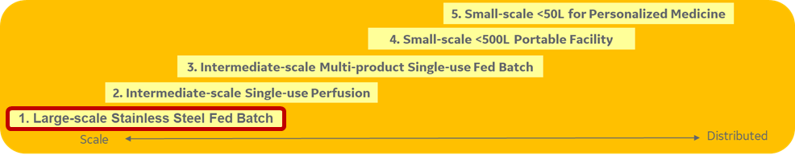
Figure 2: Technology roadmap scenarios
The model process had to conform to a specific order of unit operations to allow consistency in the discussions. The selected process outline and list of unit operations is shown in Figure 3; typical variations are the order of the two polishing steps and the position of the intermediate hold.
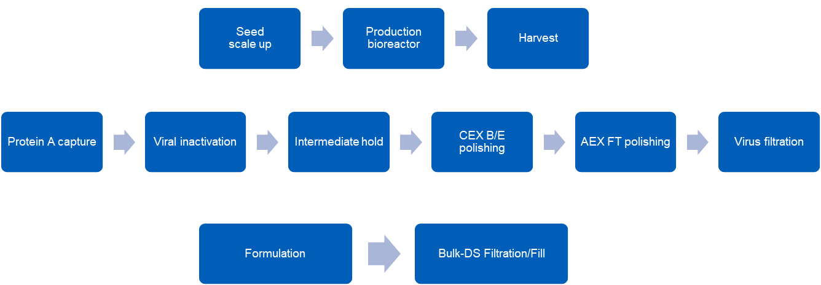
Figure 3: Process outline of unit operations in upstream, downstream and bulk drug substance formulation
CEX= Cation exchange chromatography AEX= Anion exchange chromatography
B/E= Bind/Elute mode FT=Flowthrough mode DS=Drug Substance
There is a dual purpose within the project scope that sets out to cover both ILM for better process control and opportunities to reach RTRT. The latter aspect covers both release of final drug substance and process intermediates for further processing.

3.2 Step attribute matrix
The next step in the workflow was to collect all the potentially critical quality attributes and process parameters that should be considered for the project (see Figure 3 and Table 1). To ensure the activity was both focused and manageable, raw material attributes were pronounced as out of scope. It is acknowledged that variability in raw materials (e.g. cell culture media or chromatographic resins) may constitute a substantial contribution to the overall process variation, but the control of such variability is typically reliant on off-line testing of raw materials prior to their introduction into the process. The quality attributes and process parameters were subsequently combined with the unit operations into a so-called Step Attribute Matrix (SAM) (Figure 4).

Table 1. Quality attributes and process parameters
Quality attributes | Cell culture control | Downstream control | Safety | Others
Aggregation | IgG titer | UV | Microbial safety (bioburden) | Bulk DS concentration
Fragmentation | Cell viability | Conductivity | Endotoxin | Cell-based potency assay
Charge profile | Viable cell density | pH | Virus safety | Antigen binding
 | Yeast proteins
 | Insulin
Deamidation |  | Pressure |  | FcgR, C1q and FcRn binding
Oxidation | Glucose  Amino acids  Galactose | Flow |  | Density
Glycosylation profile | Glutamate | Turbidity |  | Appearance (color)
Glycation | Glutamine | Product concentration/mass |  | Visible & sub-visible particles
Lactate

Ammonia
Non-glycosylated heavy chain | Other nutrients & metabolites
Host Cell Proteins (HCP)

Host DNA

Leached Protein A | Dissolved oxygen
 | CO₂
 | Exit gas composition
 | pH
 | Antifoam concentration
 | Metals (Cu, Mn etc)
 | Methotrexate
 | MSX
 | Osmolality
 | B-D Glucan

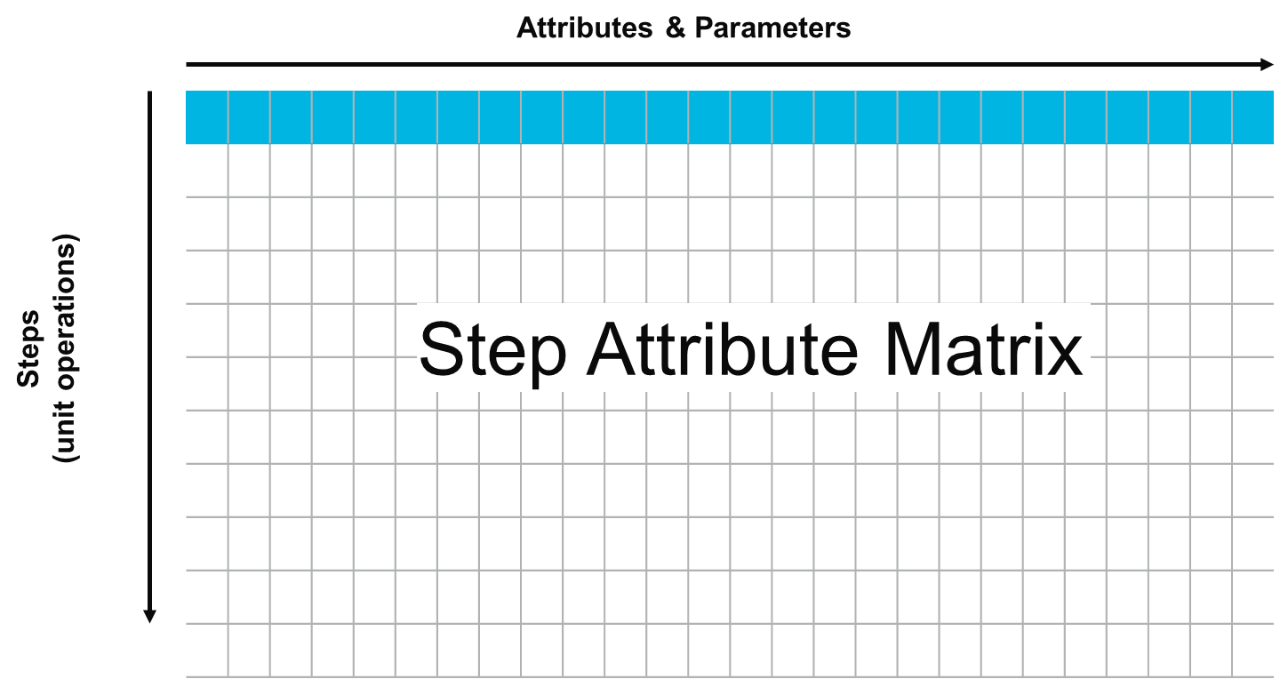
Figure 4: Step Attribute Matrix

3.3 Current and desired state
Each cell of the SAM constitutes the measurement of one attribute or parameter during a certain unit operation. Within each cell a description of the current state relating to how the measurement is performed today (if at all) and what the desired future state would look like was populated. Aspects considered for the descriptions were:
- Measurement type (what is the purpose of the measurement, see Table 2)
- Testing mode (off-line/at-line/on-line/in-line, see definitions in Table 3)
- Testing time (time from start of measurement or sampling to result)
- Desired frequency (time interval between data points) only for the desired state

Table 2: Definition of measurement types (see also Section 8. Definitions/Glossary)
In-process test | Testing of an attribute when not part of the formal control strategy e.g. an in-process test can be used to monitor process performance
In-process control | ICH Q7 [30] definition: “In-Process Control (or Process Control): Checks performed during production in order to monitor and, if appropriate, to adjust the process and/or to ensure that the intermediate or API conforms to its specifications.”  Testing of an attribute between steps, that may be needed for final release or for starting the next step e.g. in-process controls can be used to assure control of CQAs.
Process control  (feed-forward/ backward) | Used to control the process (e.g. pooling criteria)
Release testing | Final testing of drug substance according to specifications
CPV monitoring | Continued Process Verification, demonstrating process consistency over life cycle

Table 3. Definition of testing modes
Off-line | The sample is removed, isolated from, and analyzed in an area remote from the manufacturing process
At-line | The sample is removed, isolated from, and analyzed in close proximity to the process stream
On-line | The sample is diverted from the manufacturing process, and can in some cases be returned to the process stream if desired
In-line | The sample is not removed from the process stream.  The measurements can be invasive or non-invasive

3.4 Ranking
The desired state for each cell was further characterized according to three ranking criteria described in Table 4:
Table 4: Definition of ranking criteria and applied weighting
Ranking criteria | Definition | Weighting
Improves quality (Q) | Will the measurement improve product quality or reduce variability? | Yes = 2  No = 1
Critical for RTRT (R) | Will the measurement expedite release of final drug substance and/or process intermediates for further processing? | Yes = 2  No = 1
Need for change (C) | How problematic are current methods? How critical is it to change these? This was assessed based on inputs by industry Subject Matter Experts from the participating companies with respect to the difference between the current and desired state. | High=9  Medium=3  Low=1

These scoring metrics were used to construct an initial overall mathematical ranking by multiplying the weights (Q*R*C). The resulting ranked matrix is depicted in Figure 5, indicating both unit operations with large improvement potential and attributes where improvements are possible across multiple unit operations.

Figure 5. Initial mathematical ranking results
Some key points worth noting from Figure 5:
- The production bioreactor has multiple attributes with room for improvement. Several of them may be seen as incremental steps but put together may deliver a larger synergistic impact to the control of the cell culture.
- There are some opportunities associated with the Protein A capture step, but the two polishing steps have more to gain from better control. This can be attributed to the inherent robustness of the affinity step.
- Microbial safety is the attribute with the highest potential and is covered in detail by other BioPhorum activities [28]
- Product concentration and product mass is a common need for all chromatography steps but is likely addressed sufficiently well by a suitable UV detector in these types of processes.
- The quality attributes with the highest potential for improvement are charge profile, aggregates and Host Cell Proteins (HCP).

The SAM output was subjected to scrutiny by SME teams within the participating companies to allow condensation into a manageable list of cases for further development. The output was also exposed to wider industry and regulatory scrutiny through presentations at conferences (ACS National Meeting, New Orleans, March 18-22 2018, CASSS CMC Strategy Forum Summer 2018, Interphex, New York, April 2-4 2019). This iterative exercise allowed the team to shortlist ten prioritized attributes/parameters where improvement would have the largest impact for process control and/or expedited release. The list is not prioritized internally so the attributes are presented in Table 5 without any ranked order.

Table 5. List of ten prioritized attributes and parameters
Attribute/Process parameter | Unit operation
Glycosylation Profile | Production Bioreactor
Charge Profile | Production Bioreactor
 | CEX Bind & Elute
Aggregation | CEX Bind & Elute
HCP (Host Cell Proteins) | AEX Flow Through
DNA | AEX Flow Through
Cell Viability | Seed Scale Up
 | Production Bioreactor
Viable Cell Density | Seed Scale Up
 | Production Bioreactor
Glucose | Production Bioreactor
Amino Acids | Production Bioreactor
Product Titer/ Concentration | Production Bioreactor
 | Protein A Capture
 | CEX Bind & Elute
 | AEX Flow Through
 | Formulation
 | Bulk DS Filtration/Fill

The information in the SAM was also used to identify Critical Control Points (CCP), potential Release Points and Measurement for control points for the top ranked CQAs and CPPs.
- Critical Control Point: A point in the process where there's a potential to control that attribute. Some signal can allow you to modulate the process by feed-back/feed-forward control and ensure that a quality attribute is within the desired range. There can be multiple Control Points for a given attribute. See also HACCP Principles & Application Guidelines [29]:”Critical Control Point: A step at which control can be applied and is essential to prevent or eliminate a food safety hazard or reduce it to an acceptable level.”
- Release Point: The point at which RTRT would be proposed. Only one per attribute!
- Measurement for control: A point in the process where measurement of a process parameter can help control a quality attribute
The resulting CCP worksheet is shown in Figure 6 where the current release testing point also is indicated. Bioburden and Endotoxin have been included in addition to the ten prioritized attributes from Table 5.
 | Release Point |  | Critical Control Point |  | Measurement for control |  | Current state release
Figure 6. Critical Control Points mapping

The final steps in the workflow was to develop a URS for each of the ten listed attributes. These URS documents are technology agnostic and only focus on the requirements necessary to fulfil the use case, e.g. for feedback process control. The user requirements may be unit operation specific in cases where an attribute is listed in two unit operations, e.g. depending on the required data frequency. Such URS documents will be directed towards the broader industry and will act as guidance for development of new analytical solutions.
Furthermore, the financial benefit for implementation of the improved technology is described in business case calculations and can act as guidance for the industry how to prioritize activities.

User requirement specifications
The aim of the user requirements specification (URS) is to state what specifications a new method or instrument must meet, in order to be classed as ‘fit-for-purpose’. This is key to ensuring that, from a regulatory perspective, there is a clear definition of success criteria and from a business perspective, that any investment will be worthwhile. The URS documents drafted as part of this white paper are aimed at technology providers in order to guide development of systems that meet industry needs for ILM and RTRT.
The URS template contains a number of sections that cover multiple operational requirements and needs. These sections contain uniquely referenced requirements that should be consistent throughout the document and not duplicated or contradictory. Each requirement should focus on a clearly defined, testable aspect of the system but make no reference or assumption as to how this will be achieved.
The document should state clearly the intended aim of the application, named stakeholders (or stakeholder groups) and definitions of any acronyms or technical terms. Changes can be made to the document, but should be tracked in version history.
As part of stakeholder engagement, there is the opportunity to list any relevant stakeholders and their requirements /expectations of the stated method. This is of particular use to the technology supply companies in order to understand the wider impact of any technology implementation and how it will affect the end-user company as a whole.
The URS will be met when every requirement has only one interpretation and is met by the system.
This template has grouped the requirements into 12 sections:
- Scope & vision
- Functional
- Operational
- Qualification
- Quality
- Health & safety
- Environment & supporting systems
- Supply chain
- Network security
- Software security
- 21CFR Part 11
- Electronic signatures

The first section in the URS document to be completed is ‘scope and vision’. This is where the end-user details what the aim of the new method is to be, how it is currently performed (if at all), what issues need to be overcome to bring a method up to ideal requirements and any method specific definitions. It also specifies the need for a scale-down version of the technology for process development, or points to the possibility to conduct bridging studies across scales if a true scale-down version isn’t possible.
The functional requirements cover the technical specifications of the required technology, including; accuracy, precision, lower limit of quantitation, frequency of measurement and total measurement time. It is important that these requirements are viewed from a technology agnostic viewpoint as to not bias the outcome of the URS.
The document then moves onto the operational requirements, covering areas such as the operating pH, pressure and temperature ranges of the process contact parts of the system. The functional requirements interlink with the operational requirements in that the functional requirements must be met across all the ranges of the operational requirements.
Any environmental requirements such as implementation in good manufacturing practice (GMP) areas, explosive atmospheres (ATEX) or national electrical manufacturers association (NEMA) enclosures and power supplies can be captured in the ‘Environmental and supporting systems’ section. To negate the risk of supply chain issues interrupting any analytical capability, lead time requirements on any consumable components can be specified in the supply chain section.
The IT requirements (network security, software security, 21CFR Part 11 and electronic signatures) are included in the URS appendix. The template also offers the ability to include additional requirements to those listed in the main document.
The sections included in this URS template are focused on technology aspects which add value to an ILM / RTR proposition, financial aspects of this should also be considered but were deemed out of scope for this URS template exercise.
Based on the output from the process workflow section of this white paper, URS documents were completed for the ten prioritized attributes/parameters. The scope of these URS documents is focused on mAb production based on fed-batch cell culture and batch-wise downstream processing. It can be extended to further modalities and advanced manufacturing including continuous upstream and downstream manufacturing and/or single use scenarios.

Business case

5.1 Benefits of ILM-RTRT
The benefits of ILM and RTRT include both tangible and intangible benefits. The tangible benefits may include reduction of failed batches, rescue of failing batches, increases in yield, reduction in raw material or supplies costs, and reduced hours required to manufacture, test and release product. These benefits can be realized through rapid analysis of product CQAs and CPPs, trending metabolic markers, improved batch productivity, more efficient media/feed development, and less off-line analytical testing. Of note here, is that timely measurements of CPPs and CQAs can lead to more consistent processes with more rigorous control strategies. All these improvements can affect the bottom line within a manufacturing campaign; however, there are other potential benefits specifically afforded by ILM that can impact current and future bioprocesses. The ability to monitor both product attributes and process control parameters in real-time can improve process insight and allow for the development of control strategies for both productivity enhancement and more robust quality attribute control.

5.2 Drivers for ILM-RTRT
Of the many potential drivers for implementing RTRT one major driver is reduction of the lag time from completion of a manufacturing process to release of the product. Generally, following a batch process production scheme, release is delayed while routine product testing is completed. This testing includes, but is not limited to, purity, quality attribute characterization, sterility and physiochemical attributes (pH, concentration, molecular weight). In general, the time between completing a production campaign to commercial release of the product can be as long as 30 days. In theory, the faster one can release the production batch, the faster it can be sold, the faster patients can obtain their life saving medications, and the lower the value of inventory that needs to be held by the manufacturer.
In addition, as the biopharmaceutical industry moves to adopting more continuous modes of operation, both upstream and downstream, the need for real-time release is greater, as some of the potential benefits of continuous manufacturing will not be realized without a more rapid analytical scheme for releasing the material. However, even if a product can be manufactured on a continuous basis, the release process, under the current paradigm, will remain a lengthy batch process. The introduction of accurate and timely measurements, whether at-line or in-line/on-line, for commonly measured release specifications may enable RTRT of process intermediates, drug substance and drug product batches for both continuous manufacturing and the traditional batch process.

5.3 Business impact of the prioritized CQAs and CPPs
Following the construction of the step attribute matrix and mapping of the different process steps to the corresponding quality attributes, the group decided on ten prioritized process parameters and CQAs. These parameters and CQAs were chosen on their potential to yield a major impact towards RTRT and improving the quality of biopharmaceuticals by better process control, if measured in a more rapid, in-line, on-line or at-line manner. These parameters and CQAs are listed in the table below with the associated step of the process, associated control mechanism and potential impact on the process.

Table 6: Prioritized ten attributes and process parameters (sorted by CPP and CQA)
Parameter/ Quality Attribute | Process step | Action ILM can enable | Process impact | ILM or RTRT | CPP or CQA
Glucose | Production bioreactor | Tight control of glucose level | Increased yield, better control of glycoforms | ILM | CPP
Cell viability | Seed scale up  Production bioreactor | Monitor cell viability to identify when to stop cell culture and proceed to next steps in process. | Increased yield  Decrease unwanted product related impurities | ILM | CPP
Viable cell density | Seed scale up  Production bioreactor | Monitor cell density to identify when to stop cell culture and proceed to next steps in process. Can be used to control perfusion feed rates in continuous cell culture. | Increased yield  Decrease unwanted product related impurities | ILM | CPP
Amino acids | Production bioreactor | Tight control of amino acids levels | Alternative feed sources apart from glucose. Can be used to boost viability, cell density, and increase yield | ILM | CPP
Titer/ product concentration | Production bioreactor  Protein A capture  CEX bind and elute  AEX flow through  Formulation  Bulk DS filtration/ fill | Adjust process based on product concentration | Better control during cell culture and downstream; potential to increase efficiency of downstream steps by optimizing elution and filtration performance | ILM | CPP
Charge profile | Production bioreactor | Monitor charge profile as culture grows | Can produce target charge profile, to either enhance potency, or match predetermined target charge profile (i.e. biosimilars) | ILM | CQA
Glycosylation profile | Production bioreactor | Monitor glycosylation profile as culture grows | Can produce target glycosylation profile, to either enhance potency, or match predetermined target glycosylation profile (i.e. biosimilars) | ILM | CQA
Aggregation | CEX bind and elute | Monitor aggregates as they elute from the column | Increased yield by allowing more precise peak cutting | ILM | CQA
Host cell protein (HCP) | AEX  flow through | Monitor HCP removal | Critical control point allowing real-time release. No need to measure HCP downstream of this step | RTRT | CQA
DNA | AEX  flow through | Monitor DNA levels following AEX | Critical control point allowing real-time release. No need to measure DNA downstream of this step. | RTRT | CQA

From this list one can conclude that ILM of these process parameters and quality attributes can either enable RTRT or provide valuable process insight that can enable more precise process control. From a benefits stand-point, ILM of the process parameters of glucose, cell viability, viable cell density, and amino acid concentration within the production bioreactor can lead to more efficient control strategies and an increase in product yield. In contrast, ILM of CQAs may allow tailored reactor strategies to deliver a predetermined CQA profile including, but not limited to, glycosylation and charge variants. This could enable benefits in enhanced potency and safety of a product, and assist in the manufacture of biosimilars, when matching an already approved therapeutics CQA profile is necessary. It may also allow originators to set tighter specifications. The third type of benefit achieved is through ILM of process parameters and CQAs, including but not limited to titer, DNA, host cell protein and aggregation during downstream processing of the product stream. The ability to measure these product attributes and impurities in a timely fashion, in-line or on-line, can enable real-time release, given that the step in the process, in which these are monitored is the last step in the process where these attributes will no longer change. Having real-time readouts of such attributes may also allow better control of pooling criteria leading to an increase in yield. In addition, to enabling real-time release, ILM of these attributes and impurities may also allow more efficient use of expensive components of the process train (e.g. Protein A packing materials, especially in a continuous application).
Though the advantages of ILM are abundant, the development and implementation can take considerable resources in the form of time, money, personnel, and equipment. Therefore, it is essential that before pursuing the development of these technologies a well justified business case is established to demonstrate return on investment. To achieve this, it is necessary to take an objective approach to enumerate these potential benefits to justify the development of these technologies.
Additionally, in considering the business case, the long-term organizational goals and benefits should be considered. For example, the first ILM project that will replace a single, current off-line test will not yield all the potential benefits. Since a sample may still need to be collected to run other off-line tests, some benefits (e.g. labor, supplies, and materials required for sampling) may not be initially recognizable for the first in-line measurement. However, if the long-term goal is to eliminate the rest of these off-line tests, then the first project may be the proof of concept needed to move forward with the rest of the measurements. This stand-alone project will show a lower return, and depending on the specifics, this project may not be justifiable as a stand-alone business case. However, when considered as a portfolio of projects that would eliminate the need for most or all sampling and laboratory testing, the complete picture of the portfolio of projects would most likely provide the substantial benefits needed to justify the investment. The same argument can be made for implementation of RTRT where the full benefit will be realized only when all, or nearly all, off-line release tests are replaced by timely measurements during the process.

5.4 Building a business case
In building a business case, several elements shown in figure 7 must be considered. The business case is a function of the specific scenario details, underlying assumptions, projected capital costs, and the estimated operational costs and benefits, including any deferred costs. In the following sections, these items will be discussed in more detail.
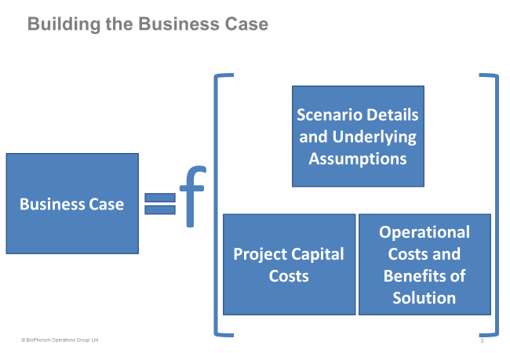
Figure 7: Elements of building a business case
For any business case, this specific information must be gathered and/or assumed. Business cases will be company and scenario specific. There are many questions that must be answered in order to define the impacts. The sections that follow provide the details regarding this information.
Scenario details and assumptions
To provide a proper business justification, the specific details of a scenario must be considered. These specifics include three areas: company specific financial information, plant-specific information, and the detailed impacts of any given potential project scenario as shown in Table 7.
Table 7: Scenario details required for a business case analysis
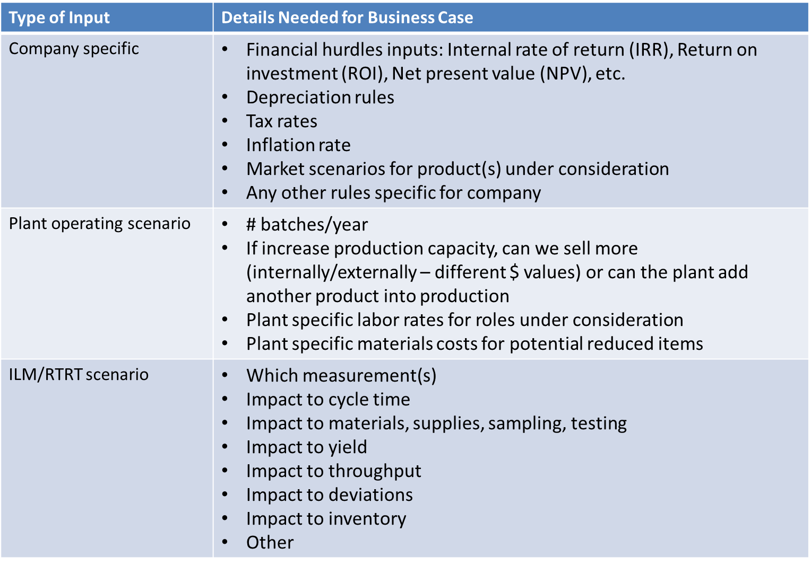
There are company specific criteria or policies that are generally used to make project investment decisions and prioritize projects. The specific hurdles that a given company uses may include the internal rate of return, return on investment, and net present value. In many cases, additional industry or company specific drivers, in addition to the purely quantitative benefits, are also considered in making these investment decisions. These drivers can include intangible benefits such as enabling digitalization and improving safety, quality, or regulatory approaches as well as ease of doing business in a complicated organization. The number of benefit years during and post the investment as per company evaluation strategies are part of the calculations. Other factors that are also used in the calculations include the tax rate and inflation rates for different types of resources (e.g. materials, equipment, support contracts, personnel costs, etc.) and the associated costs of these resources and materials as well as the depreciation rules specific to the company and type of capital project. Additionally, market scenarios for the product(s) that will be affected by these changes must be well understood and considered in determining the potential benefits. There could also be other factors that are company specific that must also be taken in to consideration in determining the applicability of benefits and how they could affect the top and bottom line of the business (e.g. expected capacity increases in a non-sold-out plant, seasonality of products, risk factors, etc.). Note that for a given company some of these inputs, such as market considerations, could also vary by plant or region.
The plant operating scenario must be defined to determine the creditable benefits for adding ILM or RTRT to the facility. Information regarding the number of batches per year, specific plant labor rates, raw material costs, in-process material costs, and supply costs must be considered in the calculations. A set of rules needs to be established for considering measurement and control improvements that will lead to decreased material losses, increased yields, and decreased cycle times (increasing facility capacity) and labor usage. Of importance in the analysis is how to consider yield improvements and cycle time improvements. If a plant is in a sold-out capacity (i.e. the company is selling or consuming everything that this plant can make each year), the benefits derived from improving the batch yield, decreasing batch losses, and increasing the number of batches can be directly translated to increased sales. If the plant is not sold out, then these benefits would result in a decrease in the cost of goods sold (COGS), i.e. as material costs (which include the raw materials and additional processing such as Clean in place/ sterilize in place to minimize contamination (CIP/SIP) and utility costs – normally translated to the inventory value of the material at the point in the process). Other things to consider could include the ability to add another product into the facility if the improvements lead to increasing the capacity of the facility enough to make room in the production schedule for additional products.
For a detailed scenario, the current process versus the new process with the ILM and/or RTRT in place will need to be evaluated to determine what the specific benefits will be. A set of rules and assumptions will need to be developed for the detailed scenario including questions such as:
- Will one off-line test be eliminated; if so, will that test alone make a difference?
- Will the number of samples required be reduced, thereby reducing the sample materials/equipment required, the work-in-progress material losses, and labor associated with these activities?
- Will this change improve the yield or plant capacity?
- If yield is improved, will the existing equipment and subsequent process steps be able to handle the increased yield?
- Will resources that are freed up from these activities be able to be reassigned to other activities or at least be able to contribute to the equivalency of their cost rates to the company’s finances?
- Are labor costs already covered in the material costs?
For a new product, these kinds of benefits could also be used to justify including this capability in the initial license.

Project capital costs
Project capital costs for implementing the technological solution include equipment, instruments, sampling systems, hardware, and software. Additionally, the following capital project associated costs must be considered: engineering required to design, build, and test the solution; project management required for the duration of the project; quality, regulatory, method validation, equipment qualification and change management required to complete the project.
Operational costs and benefits
The specific operational changes should be considered in detail for evaluating both the operational costs and benefits.
Adding technology to a manufacturing area often means that there are additional costs that must be considered as part of the financial analysis. New costs could include on-going licensing and/or support services for new software, maintenance of hardware and systems, replacement parts, consumables associated with the new solution, costs associated with any required regulatory filings and any inventory holding required for these licensing changes.
Types of benefits expected can include overall cycle time changes that can mean additional batches to be produced on site (increased throughput), batch material consumption changes, reduced supplies for sampling, reduced material losses due to sampling and testing, reduced supplies/equipment needed for testing, increasing yields, decreased deviations due to current sampling and testing processes, and reduced work in process and finished goods inventory that are held up waiting for testing or waiting for deviation resolutions that might otherwise be associated with current sampling and testing processes. Additionally, if there are opportunities to reduce resources associated with these specific tasks then this should be taken into consideration. One way to consider this is re-allocation of these resources to more meaningful activities which can affect the financial performance of the business equivalently to their costs. Note that many of these benefits are the result of better control with ILM. With better control, there would be a more consistent process with fewer deviations and potentially fewer discarded batches.
A summary of the types of costs and benefits can be seen in figure 9 below.
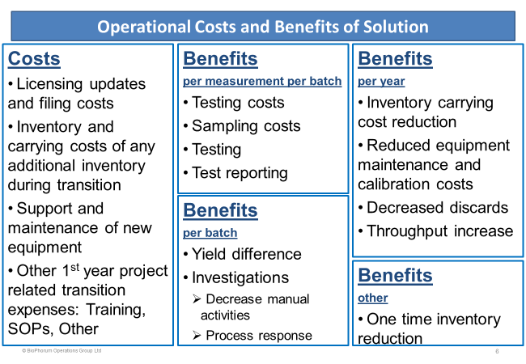
Figure 9: Operational costs and benefits to be considered

Potential Deferred Costs
Another area of consideration in evaluating a new solution is deferred costs. The costs associated with building a new plant, adding equipment, adding lab space or lab equipment could be considerable. If yield improvements or throughput improvements are sufficient to defer spending, these are the deferred costs that should be considered in the overall project portfolio financial analysis, if not already considered as part of the individual business cases.

5.5 Business case model
A spreadsheet tool was developed to evaluate the business case for each scenario. This tool is based on the basic financial model of sales revenue less operating expense equals gross profit. Gross profit less depreciation is used for calculating taxable income. Cash flow is calculated as the gross profit less the capital investment and taxes. These values can then be used to determine the financial metrics under consideration such as ROI, NPV, IRR, etc. Table 8 shows the calculation basis for these financial metrics. ROI in the spreadsheet tool is calculated from the pre-tax benefits versus the investment.
Table 8: Description of financial metrics
Financial metric | Description
Return on investment (ROI) | The pre-tax, raw value of the benefits over the duration evaluated divided by the capital outlay.
Net Present Value (NPV) | The current net worth of the series of cash flows over the duration on the project which includes the negative value of the project + the value of the benefits gained over the evaluation period using the required return on capital to devalue future cash flow benefits to current values.
Payback Period | The number of years that the cashflows would take to pay off the capital investment.
Internal Rate of Return (IRR) | The rate where the Net Present Value of the cashflows of the investment and benefits over the evaluation period equal 0. Most companies have a hurdle rate that is used to determine if an investment is worth the capital outlay.
Modified Internal Rate of Return (MIRR) | A modification to IRR that calculates the return using a cost of capital assuming that cash flows are reinvested at the cost of capital. It is often used to rank investments of similar size. It is the rate at which the NPV of the cash flow is equal to the investment.

For accurate use of this tool, one should make sure that they have adequate information about the costs of biomanufacturing, product sales prices, COGS values, and the process-specific impact of enabling ILM and/or RTRT as summarized in the figure below.
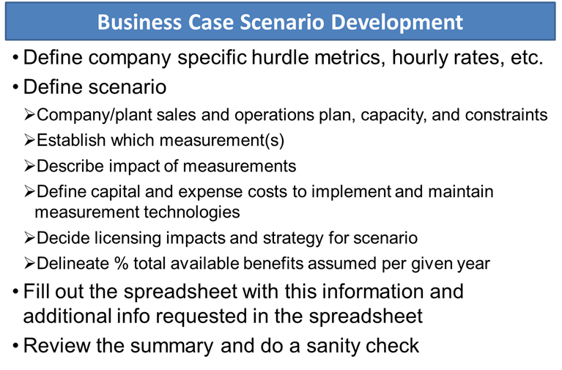
Figure 10: Business case model use
Scenarios evaluated
Using the spreadsheet tool, several scenarios were evaluated using a common set of general assumptions. The scenarios included glucose control, aggregation monitoring, amino acid control, and charge profile monitoring. Additionally, a high-level sensitivity review was completed.
General Assumptions
The common assumptions for input data used in the business case spreadsheet model are captured in figure 11 and the following bulleted list. These assumptions include financial analysis parameters, capital costs for implementation, transition expenses, and new expenses for managing and maintaining the solution.

Figure 11: General base business case assumptions
There were also several other common assumptions across all of the base business case scenarios. These included the following:
- This is for a business case for ILM only, not RTRT, so no inventory is held up as a result of this change. It is assumed that once the model is validated that testing is not required and a licensing change is not required. It can be also noted that off-line testing could be performed during the model validation period in year 0 of the project, where no savings are assumed, to support any licensing changes. In the case of a new product, no additional inventory would need to be held during the course of the commercialization process. Note that benefits do not kick in until year 1 while the project is completed in year 0. Additionally, the model allows a percentage adjustment per benefit year that can be adjusted for a specific case. The results presented in this white paper assumed 100% of the possible benefits are achieved each year, starting in year 1, while none are achieved in year 0.
- License updates and filing costs were not included in this model, as this may vary depending on what is in the current license. Also, in the case of a new product, this may or may not be an additional cost. Additionally, if one were to continue to use the traditional testing alongside ILM/RTRT, the license may not necessarily need to be changed until the traditional laboratory testing is eliminated. The ongoing benefits associated with eliminating the testing of each sample would need to be removed in this analysis.
- The scenarios which include saved labor assume that any labor saved translates to additional Cost of Goods Sold (COGS) savings. This includes whether or not labor is reassigned.
- In a sold-out case, 100% of the therapeutic product that is manufactured is sold. Consequently, these models would use the product sales price for yield improvement calculations. For the non-sold-out case, in a less than 100% sold-out scenario, the work in process material costs would be used for discards and the COGS values would be used in the yield improvement calculations.
- A yield improvement, regardless of the unit of operation under consideration, is considered as the impact to the final product yield.
- Any processing equipment downstream of the step under consideration is capable of handling any increases in yield based on the upstream ILM without a change. If a change is required, the appropriate capital, licensing, validation, inventory holding, etc. costs would need to be updated in the model.
- 15kg of final Bulk Drug Substance (BDS) product per batch
- 20 batches per year
- COGS of $100/gram
- $50/hour of labor for all sampling and other labor costs
- $5 for supplies/equipment/reagents required per sample tested
- Any yield improvements based on running a unit operation longer assumes the applicable equipment (e.g., bioreactor) is not a bottleneck in the process
- The yield improvement applies to 50% of batches

There were several assumptions that were specific to each measurement under consideration. These are captured in Table 9.

Table 9: Specific business case savings assumptions (ILM/RTRT versus current state) (per measurement per batch unless otherwise stated)

Description | Aggregation  CEX bind and elute | Amino Acids  Bioreactor | Charge Profile  Bioreactor | Glucose  Bioreactor
Time to prepare/perform an individual test (hands on time) | 120 min | 240 min * | 180 min | 5 min
Second person verification time of the test | 5 min | 5 min | 60 min | 5 min
Time to collect and input data into system | 10 min | 60 min * | 5 min | 10 min
Time to correct error and data in system | 10 min | 10 min | 5 min | 10 min
Time to verify data in system | 10 min | 10 min | 5 min | 10 min
Time to review prior to release | 10 min | 10 min | 5 min | 10 min
No. of measurements per batch | 1 | 14 | 8 | 15
*Estimate includes sample preparation and data analysis for all amino acids

As a best practice, any business case specific assumptions for user specific scenarios should be documented for future reference. Business case specifics will vary by application, by site, by region and by company.
Evaluated benefits discussion
There are many potential benefits for ILM and RTRT which can include savings that occur on a per measurement per batch basis, a per batch basis, an annual basis, or as a one-time basis. For this business case for ILM the following benefits were considered:

Per measurement per batch benefits
Materials test costs current state versus future state
Sample collection and management costs
Testing
Test data reporting costs

Per batch benefits
Better yield (tighter control)
Reduced investigations related to manual sampling and testing
Reduced investigations due to faster process responses

Per year benefits
Reduced inventory carrying cost
Lab equipment maintenance and calibration costs
Decreased production material losses - zero yields
Reduced discards (average/year)
Increased throughput

One-time benefits
Decreased inventory
Deferred capital costs
Deferred hiring of new resources

Each of these benefits are described below. In the model, there are adjustment factors that can be used to assume a certain percentage realization for many of these benefits as well as the total annual benefits, to account for the adjustments for using new technology or assuming a less than 100% of the potential benefit.
Note that any labor benefits that one chooses to incorporate into the model are assumed to be worth their value in some other productivity measure (such as improving yield, not needing to backfill a vacated position, etc.) and can be counted as a benefit.
Material test benefits include the reduction in costs of the supplies used to collect and transfer the samples, the value of the material lost in sampling, and reagents or other supplies used to test the sample. This benefit may not apply for a single measurement as samples are often taken to the lab for multiple tests. However, in some cases a single measurement may require additional sampling throughout the batch which is not required for other tests.
Sample collection and management benefits include the reduced labor costs associated with no longer requiring personnel to take samples.
Testing benefits include the reduction in the labor costs associated with preparing, testing, and cleaning up the testing area, and any second person verifications required.
Test reporting cost benefits include the reduction in labor associated with any manual data collection, input of data into systems, verification, correction of errors, and review prior to release.
Better yield benefits are estimated as a % of increase in yield over a % of batches. This assumes that better ILM of the particular parameter of interest would lead to the better control of the batch which would generally result in some % of batches that would have a better yield.
Reduction in investigations due to faster process responses benefits are the result of faster and better control when a parameter is measured in real time and adjustments can be made to prevent investigations from occurring. Additionally, when the testing is completely in-line and off-line tests are eliminated, the testing deviations could also be eliminated. This benefit includes labor associated with investigations and costs that could be associated with any additional testing that may be required as a result of a deviation.
With fewer investigations and faster, easier access to real-time measurement data, inventory may be able to be released faster. This benefit in the model would account for any reductions in the extra cost of holding that inventory for a longer duration than anticipated (e.g. cost of storage/warehousing, the opportunity cost tied up in the held inventory, etc.). The model permits adjustment of a factor for a realizable benefit in addition to the actual inventory carrying cost %. Additionally, a one-time benefit in the model, is the cash value of the decreased inventory. This is a one-time benefit only as it would not be a recurring annual benefit, only the inventory carrying cost would be a recurring benefit. Note that in the case of a license change, there may be an inventory cost that must be added instead of realizing a benefit until the associated license updates are approved.
Lab equipment maintenance and calibration costs can be eliminated and can be counted as a benefit, if that analytical method will no longer be used. It is assumed that this is true for year 1 and beyond in the business case analysis. Note that equipment maintenance and calibration costs associated with any new equipment required is included in the cost section of the analysis.
Decreased zero-yielded lots are considered with the reduction in losses of raw materials only being considered. This could also include CIP/SIP costs for a complete representation. Although this is available in the model, it was not used in the analysis.
Similarly, if a significant deviation can be prevented that would reduce a completed lot from being discarded, this benefit could be included. Although this is available in the model, decreased discards were not used in the analysis.
For a sold-out plant, if having ILM capabilities (e.g. not needing to hold a bottleneck step up waiting for test results) were to increase the throughput of the plant, the saleable value of any resulting additional lots could be a benefit. Although this is available in the model, it was not used in the analysis.
Other one-time benefits include deferred costs, both for capital and for hiring of additional resources. These benefits would only occur in the year in which the costs would be not spent. This was not considered in this model, but it is another benefit to consider for a thorough, complete evaluation.

Results discussion
Using the spreadsheet tool and the assumptions previously noted, four base case business scenarios were evaluated. The benefits analysis summaries for the base cases for amino acids, charge profile, aggregation and glucose are shown in the table below. The base case assumes that samples are still taken for other measurements but that the testing is performed with the new ILM method, not using the QC lab-based method. The total capital allocated for the base case is $600,000.
Table 10: Base case scenarios
Analysis | Scenario | Total Capital | IRR | MIRR | ROI | NPV | Payback
A | Amino Acids: Base Case | ($600,000) | 24.9% | 15.3% | 22.8% | $507,100 | 3.79
B | Charge Profile: Base Case | ($600,000) | 17.5% | 12.3% | 14.9% | $268,266 | 5.08
C | Aggregation: Base Case | ($600,000) | 11.4% | 9.4% | 9.1% | $91,266 | 6.79
D | Glucose: Base Case | ($600,000) | 13.5% | 10.4% | 11.0% | $150,446 | 6.10

Over the course of building and evaluating these four business cases, several patterns can be noted. The major contributor to savings is the potential for increased batch yield. For example, if fine tuning the glucose feed control using ILM can increase the BDS yield by a meager 1% on 50% of the 15kg BDS batches (20 per year), then this yield improvement using a COGS of $100/g results in a calculated benefit of $150,000/year. See Table 11 for the calculated benefits.
Table 11: Base case benefits

With these analyses, each plant manager or process engineer will have to think holistically about the entire process to fully calculate the ROI for that specific cell-line/product. Questions to be considered include the following:
- How often do I use these measurement results to feed or take control actions to regulate the process?
- How often do I measure?
- If I had real-time measurements, what would I change?
- Does having this measurement reduce the sample size or number of samples I need to take?
Understanding the answers to these questions will greatly help in predicting the ROI in each individual case and assist in identifying and designing the ILM measurement strategy to deliver the best business return possible.
Business case high-level sensitivity analysis
A high-level business case sensitivity analysis was also performed. Several scenarios have been considered to complete this analysis (as shown in Table 12). The base case scenarios were completed for the four attributes. The glucose base case was then used to compare some of the other factors in the business case such as the following:
- excluding versus including benefits for materials used to take samples and recovery of product that would have been lost in a sample (compare D with F)
- varying the capital costs (compare E, F, and G; also compare D, H, and I)
- changing the number of batches per year that can achieve these benefits (compare D with J)
- altering the yield (compare D with K)

The results of this analysis are shown in the sensitivity analysis financial results and benefits results tables 12 and 13 below.

Table 12: Sensitivity analysis financial results
Analysis | Scenario | Total Capital | IRR | MIRR | ROI | NPV | Payback
A | Amino Acids: Base Case | ($600,000) | 24.9% | 15.3% | 22.8% | $507,100 | 3.79
B | Charge Profile: Base Case | ($600,000) | 17.5% | 12.3% | 14.9% | $268,266 | 5.08
C | Aggregation: Base Case | ($600,000) | 11.4% | 9.4% | 9.1% | $91,266 | 6.79
D | Glucose: Base Case | ($600,000) | 13.5% | 10.4% | 11.0% | $150,446 | 6.10
E | Glucose: Including Samples; 500K Capital | ($500,000) | 41.4% | 20.8% | 42.6% | $920,780 | 2.32
F | Glucose: Including Samples; 600K Capital | ($600,000) | 34.6% | 18.7% | 34.0% | $845,753 | 2.79
G | Glucose: Including Samples; 700K Capital | ($700,000) | 29.5% | 17.0% | 27.8% | $770,726 | 3.25
H | Glucose: 500K Capital | ($500,000) | 17.5% | 12.3% | 15.1% | $225,473 | 5.09
I | Glucose: 700K Capital | ($700,000) | 10.5% | 8.9% | 8.2% | $75,419 | 7.12
J | Glucose: 30 Batches | ($600,000) | 28.1% | 16.5% | 26.4% | $615,136 | 3.40
K | Glucose: 2% Yield | ($600,000) | 37.7% | 19.7% | 37.8% | $960,512 | 2.56

Table 13. Sensitivity analysis benefits results

If the sample can be eliminated completely by moving to an in-line measurement, then including benefits for materials used to take samples and the recovery of product that would have been lost in a sample makes the business case more favorable (comparing D with F). The larger the capital costs (comparing E, F, and G or comparing D, H, and I), the lower the return for the project. In comparing number of batches per year, the benefits will be greater when there are more batches produced in the facility (comparing D with J). If yield improvements can be made for more than 50% of the batches or if better yield improvements are achieved, the business case is better (comparing D with K). The most sensitive items in a non-sold out business case are the yield improvements, number of batches, and number of samples per batch.

Additionally, note that whether a facility is in a sold-out or non-sold-out scenario, the business case is sensitive to the number of batches per year, size of batches, and the project costs. Reduced deviations as well as labor and materials costs could also be an impact depending on the nature of the business case. Also, in either case, capital cost avoidance benefits could be a significant benefit that could be considered if additional capacity can be used at an existing facility to meet current product or additional product demands.
Based on this information, we can also deduce that the most sensitive items in a sold-out business case would be the throughput capacity improvements, yield, and decreasing samples per batch. This is even more significant in the sold-out case, since the sales price of the product, instead of the COGS, can be used to estimate the benefits.

5.6 Business case summary
In summary, there are many tangible and intangible benefits to in-line monitoring alone, while there are additional benefits to be gained if achieving real-time release. The most significant tangible benefits are the results of better process control which lead to improved yields and fewer product inventory problems. From an intangible benefits perspective, it could be invaluable to gain process understanding from such timely process measurements. This knowledge could then be used for activities such as rationale for production improvements, better understanding sources of process variability, and enabling bidirectional knowledge transfer between manufacturing and process development.

Although, in some cases, tangible benefits alone may not easily justify an individual ILM measurement, it is beneficial to start with one scenario as a proof of concept with the intention of including additional measurements in the future. This will help to ease operations, quality, and manufacturing technology personnel into the new ways of accessing process information. It can also be the benchmark for how to address any regulatory related questions. The first project can be an accelerator or enabler for a portfolio of future projects where these types of measurements can combinatorically be used for process control, release decisions, and production optimization.
Finally, although these business cases showed some specific benefits, note that a plant specific business case will vary by application, site, region, and company.

Conclusion and path forwards
Currently, the majority of product characterization and impurity testing in the biopharmaceutical industry is mostly performed by off-line testing and some at-line testing. This results in a long lead time for release of drug product [6]. Achieving a reduced time-to-release for drug product has been a major goal of the industry, as it represents a way to reduce the cost of production and accelerate the speed to market. Specifically, the development of in-line monitoring technologies is a fundamental enabler of real-time product release.
In this white paper, we first outlined an approach to evaluate and identify the most important critical quality attributes and in-process control parameters to move from off-line testing in the Quality Control laboratory to in-line, on-line or at-line testing on the manufacturing floor. This approach is summarized in the Process Workflow section. Briefly, a Step Attribute Matrix was constructed based on all quality attributes and process parameters under consideration. A set of criteria was then established and used to rank the attributes and parameters in each unit operation according to their potential impact on improved process control and/or expedited release. These potential improvement opportunities were then prioritized to construct a “Top Ten” list. Additionally, the critical control point for each prioritized attribute was identified and used for the development of theoretical control strategies for that given attribute. In order to convey this information and the desired performance of instrumentation to potential technology developers, a user requirement specification (URS) was compiled for each of these attributes. These URSs contain key operational requirements and serve as a guide for technology suppliers and innovation hubs in the development of systems that will meet industry standards for ILM and RTRT.
After development of the necessary technologies to enable these ILM-RTRT strategies, the next hurdle in actualization is the implementation of these technologies in new or pre-existing bioprocesses. In order to justify investment in either the development or acquisition of new technology for in-line monitoring, a strong business case needs to be made. Of critical importance are the cost of implementation and the subsequent benefits in terms of cost and lead time reduction. Key factors that influence these considerations were presented in the Business Case section, which provides a step-by-step guide to building a business case. These concepts were utilized to build business cases for four prioritized attributes/parameters from the “Top Ten” list.
Additionally, a discussion on considerations, benefits, and application of the business case is included herein. The high-level sensitivity analysis can also be used to demonstrate what business case parameters can be important in evaluating the impact of implementing this type of technology. This will specifically be useful during initial governance proceedings. The goal of this industry wide collaborative team is to offer best practices and provide insight for the biopharmaceutical industry of how to use existing regulatory guidelines to develop a sustainable ILM-RTRT program.
While not addressed in the business case assessment, another potential benefit of ILM-RTRT implementation is the opportunity to employ new regulatory tools enabled by ICH Q12, such as performance-based established conditions. These tools can be expected to increase regulatory flexibility and reduce the number of post-approval submissions required, which in turn should facilitate innovation and the adoption of improved control technologies in existing commercial processes, with benefits to improved assurance of product quality and consistent supply to patients as well as to the business case.
In summary, the key principles highlighted in this white paper provide a basis for the evaluation and development of new proof-of-concept ILM-RTRT technologies. In order to push the actualization of ILM-RTRT forward, close collaborations between equipment suppliers, technology developers, innovation hubs and biologics end-users will be crucial to the development and implementation of ILM-RTRT technologies. The potential benefits of ILM-RTRT include significant gains in product quality, process consistency, efficiency and supply while greatly reducing product release timelines. As the biopharmaceutical industry moves towards next generation biomanufacturing concepts such as continuous bioprocessing, automated processing and on-demand production, ILM-RTRT technologies will also provide vital real-time information to facilitate effective in-process control strategies. As the field of biopharmaceuticals continues to evolve, to include a greater amount of biosimilars, more complex molecular formats, and enhanced automation; the ability to extract a greater amount of in-process data to enhance process understanding and control will likely represent a major form of competitive advantage. The investment in ILM and RTRT enabling technologies represents a potential means to improve efficiency and effectiveness of control of product quality and process consistency as the industry moves into the future, and ultimately minimize the cost of medicines thereby enhancing accessibility for the global population. This is perfectly aligned with the industry vision expressed in the BioPhorum BioManufacturing Technology roadmap [6].

References
1. EvaluatePharma. World Preview 2018, Outlook to 2024 Executive Summary. 2018.
2. ICH Harmonized Tripartite Guideline, Q8(R2) Pharmaceutical Development; International Conference on Harmonisation of Technical Requirements for Registration of Pharmaceuticals for Human Use, 2009
3. ICH Harmonised Tripartite Guideline Q11, Development and Manufacture of Drug Substances (Chemical Entities and Biotechnological/ Biological Entities), 2012; International Conference on Harmonisation of Technical Requirements for Registration of Pharmaceuticals for Human Use
4. PAT- A Framework for Innovative Pharmaceutical Development, Manufacturing, and Quality Assurance, Guidance for Industry: US Food and Drug Administration, September 2004.
5. Agency, European Medicines. Guideline on Real Time Release Testing (formerly Guideline on Parametric Release). 2012.
6. BioPhorum’s BioManufacturing Technology Roadmap [Online] https://www.biophorum.com/phorum/technology-roadmapping/trm-projects-2
7. Quality Implementation Working Group on Q8, Q9 and Q10 Questions & Answers (R4), November 11, 2010, ICH International Conference on Harmonisation of Technical Requirements for Registration of Pharmaceuticals for Human Use
8. Guideline on Real Time Release Testing (formerly Guideline on Parametric Release), 29 March 2012, Committee for Medicinal Products for Human Use (CHMP), European Medicines Agency (EMA)
9. ICH Harmonized Tripartite Guideline, Q12, Technical and Regulatory Considerations for Pharmaceutical Product Lifecycle Management, International Conference on Harmonisation of Technical Requirements for Registration of Pharmaceuticals for Human Use, 2019
10. ICH Q12 Annexes, Technical and Regulatory Considerations for Pharmaceutical Product Lifecycle Management, International Conference on Harmonisation of Technical Requirements for Registration of Pharmaceuticals for Human Use, 2019
11. ICH Harmonized Tripartite Guideline Q10, Guidance for Industry, Pharmaceutical Quality System: International Conference on Harmonisation of Technical Requirements for Registration of Pharmaceuticals for Human Use, 2009
12. Use of HPLC as an Enabler of Process Analytical Technology in Process Chromatography. Tiwari, A, et al. 90, 13, (7824-7829): Analytical Chemistry, 2018.
13. At‐line process analytical technology (PAT) for more efficient scale up of biopharmaceutical microfiltration unit operations. Watson, D S, et al. 32, 1, (108-115): Biotechnology Progress, 2015.
14. Process Analytical Technology (PAT) for Biopharmaceutical Products: Part 1: Concepts and Applications. Read, E: Biotechnology and Bioengineering, 2009.
15. Process Analytical Technology (PAT) for Biopharmaceutical Products: Part 2: Concepts and Applications. Read, E: Biotechnology and Bioengineering, 2009.
16. Advances in downstream processing of biologics – spectroscopy: an emerging process analytical technology. Rudt, M: Journal of Chromatography A, 2016.
17. Raman spectroscopy as process analytical technology for pharmaceutical manufacturing and bioprocessing. Esmonde-White, K: Analytical and Bioanalytical Chemistry, 2017.
18. Closed Loop control of Lactate Concentration in Mammalian Cell Culture by Raman Spectroscopy Leads to Improved Cell Density, Viability, and Biopharmaceutical Protein Production. Matthews, T E, et al: Biotechnology and Bioengineering, 2016.
19. In-Line Monitoring of amino acids in mammalian cell cultures using Raman spectroscopy and multivariate chemometric models. Bhatia, H, et al: Engineering in Life Sciences, 2018.
20. On-line ion exchange liquid chromatography as a process analytical technology for monoclonal antibody characterization in continuous bioprocessing. Patel, B A, et al. 89(21):11357–11365. 525: Analytical Chemistry, 2017.
21. Undey, Applied advanced process analytics in biopharmaceutical manufacturing: Challenges and prospects in real-time monitoring and control. Undey, C: Journal of Process Control, 2010.
22. Predictive monitoring and control approaches in biopharmaceutical manufacturing. Undey, C, et al: European Pharmaceutical Review, 2015.
23. ASTM E2629-11: Standard Guide for Verification of Process Analytical Technology (PAT) Enabled Control Systems: ASTM International, 2011.
24. Guidance for Industry Process Validation: General Principles and Practices, January 2011, Revision 1, U.S. Department of Health and Human Services, Food and Drug Administration
25. ICH Harmonized Tripartite Guideline, Q2(R1), Validation of Analytical Procedures: Text and Methodology, International Conference on Harmonisation of Technical Requirements for Registration of Pharmaceuticals for Human Use, 2005
26. ICH Harmonized Tripartite Guideline, Q9, Quality Risk Management, International Conference on Harmonisation of Technical Requirements for Registration of Pharmaceuticals for Human Use, 2005
27. Opportunities and challenges of real-time release testing in biopharmaceutical manufacturing. Jiang, M: Bioengineering and Biotechnology, 2017.
28. BioPhorum, Rapid Detection of Bacteria and Viruses in Bioprocess Samples: Justification, Regulation, Requirements and Technologies – How can industry achieve broad adoption? 2019
29. HACCP Principles & Application Guidelines. US Food & Drug Administration. [Online] https://www.fda.gov/food/hazard-analysis-critical-control-point-haccp/haccp-principles-application-guidelines#defs
30. ICH Harmonized Tripartite Guideline, Q7 Good Manufacturing Practice Guide for Active Pharmaceutical Ingredients, International Conference on Harmonisation of Technical Requirements for Registration of Pharmaceuticals for Human Use, 2000

Definitions/Glossary
Term | Definition
At-line | The sample is removed, isolated from, and analyzed in close proximity to the process stream
CIP/SIP | Clean in place/ sterilize in place to minimize contamination
Control Strategy | ICH Q10 (9) definition: “A planned set of controls, derived from current product and process understanding that ensures process performance and product quality. The controls can include parameters and attributes related to drug substance and drug product materials and components, facility and equipment operating conditions, in-process controls, finished product specifications, and the associated methods and frequency of monitoring and control”
Cost of Goods Sold (COGS) | Refers to the direct costs of producing the goods sold by a company. It includes labor and indirect expenses.
CPV monitoring | Continued Process Verification, demonstrating process consistency over life cycle
Critical Control Point | A point in the process where there's a potential to control for that attribute. Some signal can allow you to modulate the process and ensure that a quality attribute is within the desired range. There can be multiple Control Points for a given attribute.
Critical Process Parameter (CPP) | ICH Q8(R2) (2) definition: “A process parameter whose variability has an impact on a CQA and therefore should be monitored or controlled to ensure the process produces the desired quality”
Critical Quality Attributes (CQA) | ICH Q8(R2) (2) definition: “A physical, chemical, biological, or microbiological property or characteristic that should be within an appropriate limit, range, or distribution to ensure the desired product quality”
In-line | The sample is not removed from the process stream.  The measurements can be invasive or non-invasive
In-line monitoring (ILM) | Timely measurements made to improve process control. Depending on the time scale of the unit operation they can be performed by in-line/on-line or potentially at-line measurements.
In-process control | ICH Q7 [30] definition: “In-Process Control (or Process Control): Checks performed during production in order to monitor and, if appropriate, to adjust the process and/or to ensure that the intermediate or API conforms to its specifications.”  Testing of an attribute between steps, that may be needed for final release or for starting the next step e.g. in-process controls can be used to assure control of CQAs
In-process test | Testing of an attribute when not part of the formal control strategy e.g. an in-process test can be used to monitor process performance
Internal Rate of Return (IRR) | This is the rate where the Net Present Value of the cashflows of the investment and benefits over the evaluation period equal 0. Most companies have a hurdle rate that is used to determine if an investment is worth the capital outlay.
Measurement for control | A point in the process where measurement of a process parameter can help control a quality attribute
Modified Internal Rate of Return (MIRR) | This is a modification to IRR that calculates the return using a cost of capital assuming that cash flows are reinvested at the cost of capital. It is often used to rank investments of similar size. It is the rate at which the NPV of the cash flow is equal to the investment.
Net Present Value (NPV) | This is the current net worth of the series of cash flows over the duration on the project which includes the negative value of the project + the value of the benefits gained over the evaluation period using the required return on capital to devalue future cash flow benefits to current values.
Off-line | The sample is removed, isolated from, and analyzed in an area remote from the manufacturing process
On-line | The sample is diverted from the manufacturing process, and can in some cases be returned to the process stream if desired
Payback Period | This is the number of years that the cashflows would take to pay off the capital investment.
Process Analytical Technology (PAT) | FDA PAT Guidance [4] and ICH Q8(R2) [2] definition: “A system for designing, analyzing, and controlling manufacturing through timely measurements (i.e., during processing) of critical quality and performance attributes of raw and in-process materials and processes, with the goal of ensuring final product quality”
Process Control  (feed-forward/ backward) | Used to control the process (e.g. pooling criteria)
Quality by Design (QbD) | ICH Q8(R2) [2] definition: “A systematic approach to development that begins with predefined objectives and emphasizes product and process understanding and process control, based on sound science and quality risk management”
Real-Time Release Testing (RTRT) | ICH R8(R2) [2] definition “The ability to evaluate and ensure the quality of in-process and/or final product based on process data, which typically include a valid combination of measured material attributes and process controls”  Electronic systems, PAT and advanced process control strategies working in concert to enable raw material and product release contemporaneously with Drug Substance/Drug Product manufacture, thereby reducing reaction time to demand signals, lower inventory and fewer process deviations. This aspirational real-time release testing goal is to encourage the development and regulatory acceptance of rapid methods and technology platforms to replace long lead-time assays and to reduce the quality assurance review time for methods by converting them to validated in-line, on-line, or at-line tests.
Release point | The point at which RTRT would be proposed. Only one per attribute.
Release testing | Final testing of DS according to specifications
Return on Investment (ROI) | This is the pre-tax, raw value of the benefits over the duration evaluated divided by the capital outlay.
Step Attribute Matrix (SAM) | A matrix mapping the measurement status for process parameters and quality attributes in each unit operation (step)
User Requirement Specification | A detailed document that describes the required attributes of a method/instrument

